Mini Project

# Question

Create a program for a school raffle that:

* Uses a procedure to *allow the user* to input the name and D.O.B of a student.
* Inserts that name into a list.
* Continues in a loop to enable more than one student can be entered.
* Has a text interface that improves presentation.
* Prints the name and D.O.B of the winner of the raffle
* Allows the user choose whether or not they want to view that list.
  + E.g. want to view list? Enter Y or N.

Extra marks awarded in the program if you can make your program use two separate lists for the name and the D.O.B.

## Task 1

Create a flowchart for the question. Remember to break down the question thoroughly.

## Task 2

Create your testing plan for the program. Ensure that you test the program with ‘planned’ inputs, highlighting the desired outcome and the actual outcome.

## Task 3

Create the program. Ensure that you use comments that will show your understanding of the program and the features you have incorporated.

## Task 4

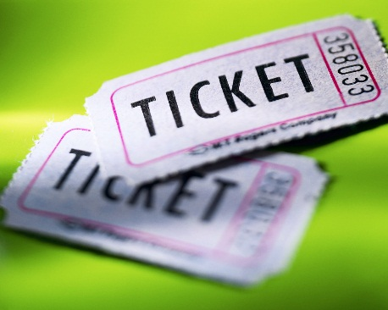Conclude your mini project by producing an evaluation of whether or not your program has met the specification. Make sure you include any faults/problems that you may have had, as well as what you feel worked well in your program, and what could be improved.

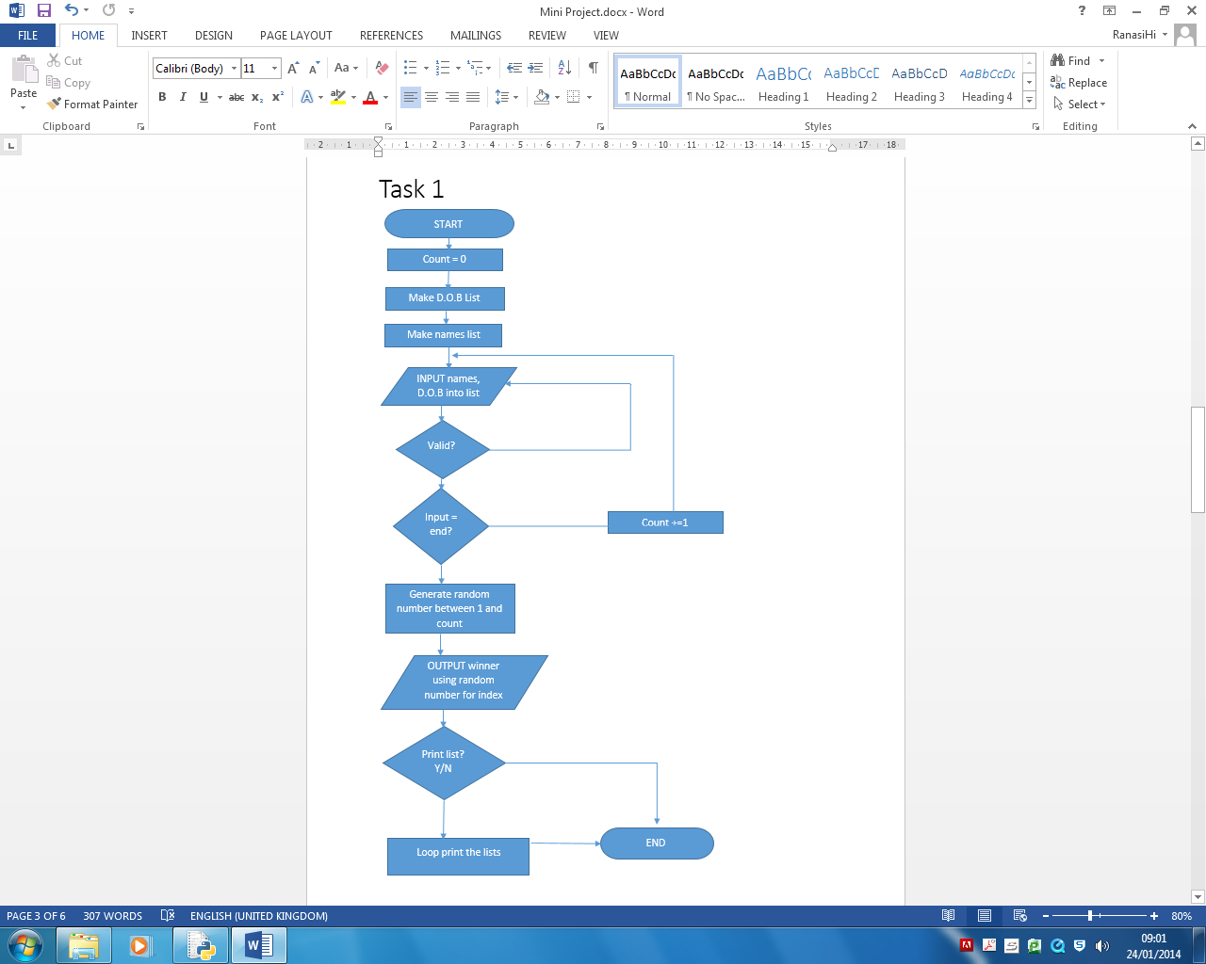

Task 2

|  |  |  |  |  |  |  |  |
| --- | --- | --- | --- | --- | --- | --- | --- |
| No. | Description | Date | I/V/E | Expected Output | Actual Output | P/F | Comment |
| 1 | Entering valid name and Date of Birth | 24/01/2014 | V | Passes validation and enters list |  |  |  |
| 2 | Entering number as name | 24/01/2014 | I | Prints error and asks to be corrected |  |  |  |
| 3 | Entering letters as date of birth | 24/01/2014 | I | Prints error and asks to be corrected |  |  |  |
| 4 | No values entered | 24/01/2014 | I | Prints error and asks to be corrected |  |  |  |
| 5 | Entered non-existent date of birth | 24/01/2014 | E | Prints error and asks to be corrected |  |  |  |
| 6 | Not entered two forward slashes when writing date of birth | 24/01/2014 | I | Prints error and asks to be corrected |  |  |  |
| 7 | Entered end | 24/01/2014 | V | Continue program and produce winner |  |  |  |
| 8 | Entered values other than Y or N for printing list | 24/01/2014 | I | Prints error and asks to be corrected |  |  |  |
| 9 | Entered Y | 24/01/2014 | V | Prints the list |  |  |  |
| 10 | Entered N | 24/01/2014 | V | No list printed |  |  |  |

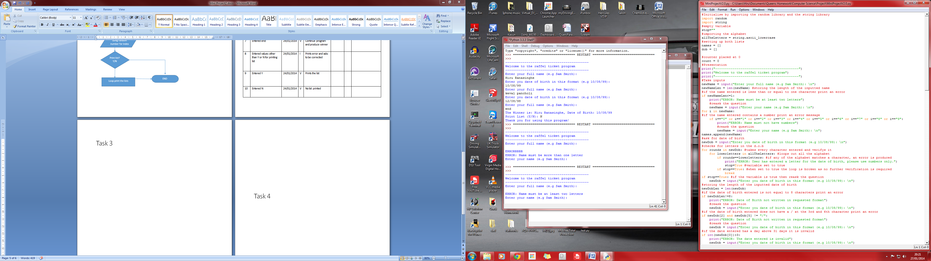Task 3

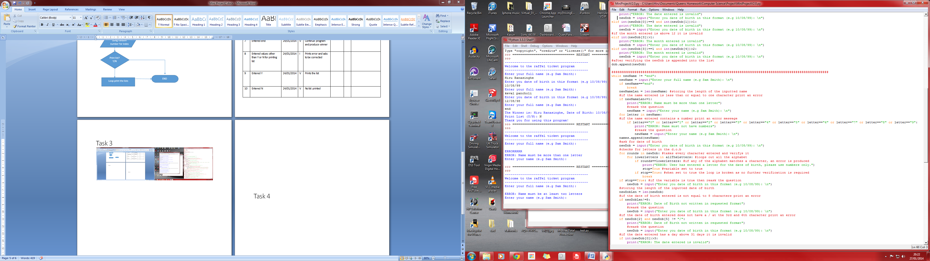

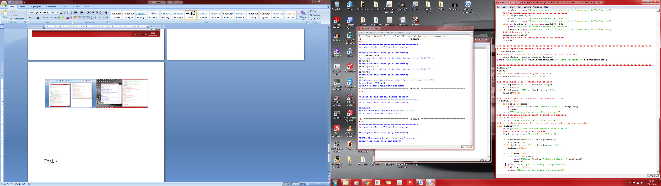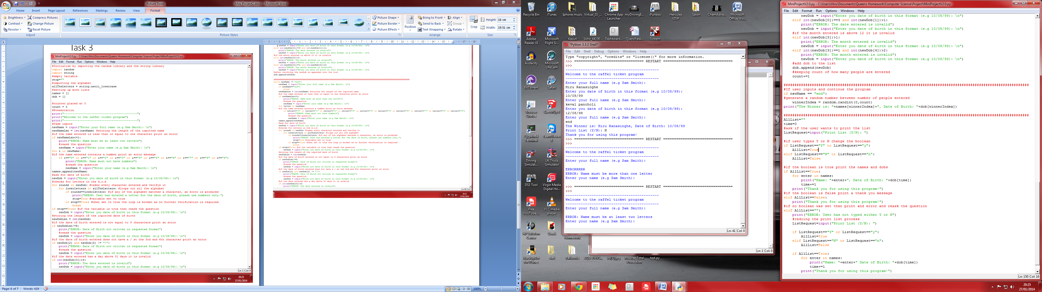

Task 4

I believe that my program has met the specification, as it can do what was requested by the original design. This includes functions such as storing names with date of births, producing a winner and asks the user whether or not to print the raffle list. In addition, I have included into my program several verifiers. These will ensure that the user cannot enter invalid entries, such as numbers of names or letters for date of births more than one letter for the names.

During the process of making this program I have experienced problems where the program will not run due to the random number generated to produce a winner was out of range and that some of the verifiers didn’t do their job. Admittedly, the verifiers only verify the first input. The program re-asks the question but it does not verify the second try. Also, if the user enters a capital letter in the date of birth letter verifier, it will not be detected, as the verifier only checks for lower case letters.

I feel as if I have worked as hard as I could in this project. Even though this may be true, there is still room for improvement. If the program verifies the second try and can detect uppercase letters then the program should be fool proof.